Maintain Student Data

You can submit a request to update your student’s current year records at any time, such as an address or phone number change.

Update current year data as needed.

- Go to your Parent Portal account. A link is on the Website Parents Page under Grades online or Registration.

2.ASCENDER Parent Portal > My Account

❏ From the My Account page (found by clicking person in right upper corner), click Maintain Student Data.

The Student Data Maintenance page opens.

3. In the left-side navigation bar, click Data Update Forms to expand and
view the forms that can be updated.

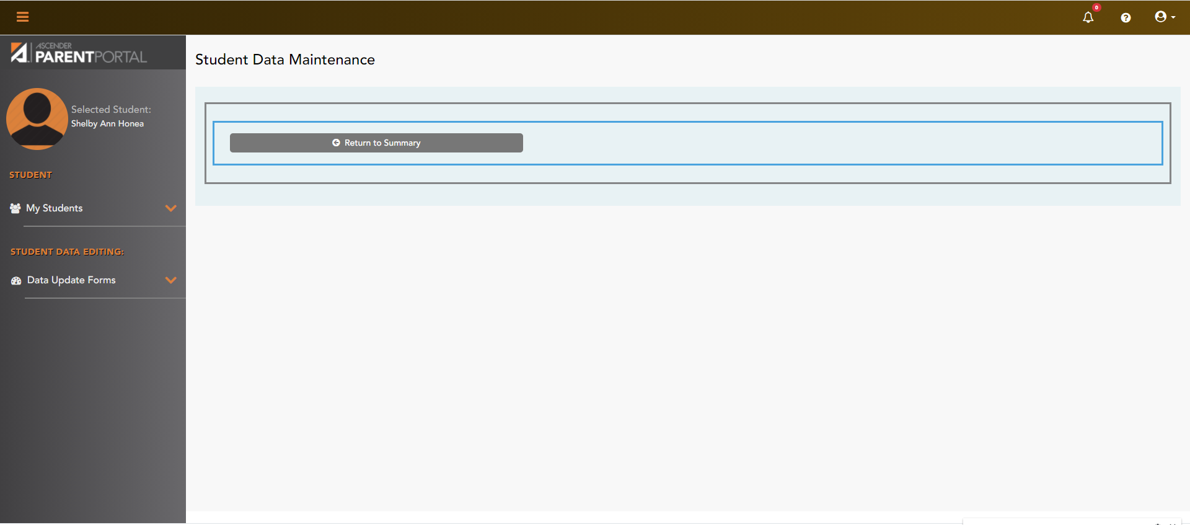

4. Click the form name, and the form opens on the right. The Page named Contacts will allow you to update Parent Contacts.

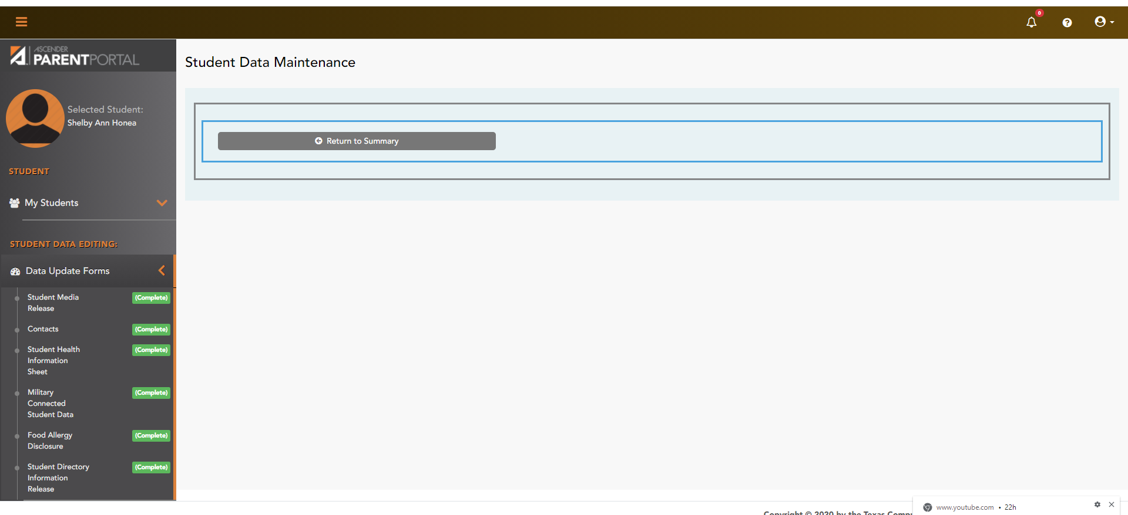

5. Type over existing text with new information or fill in blank information. Please make sure we have a primary phone, mailing address and physical address.

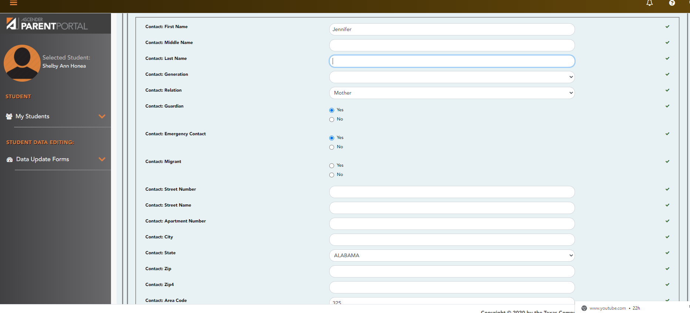

You can edit any existing contacts by clicking on the name at the top of this page or add someone by clicking on the ADD Contacts button. The first name is listed as the Primary Contact.
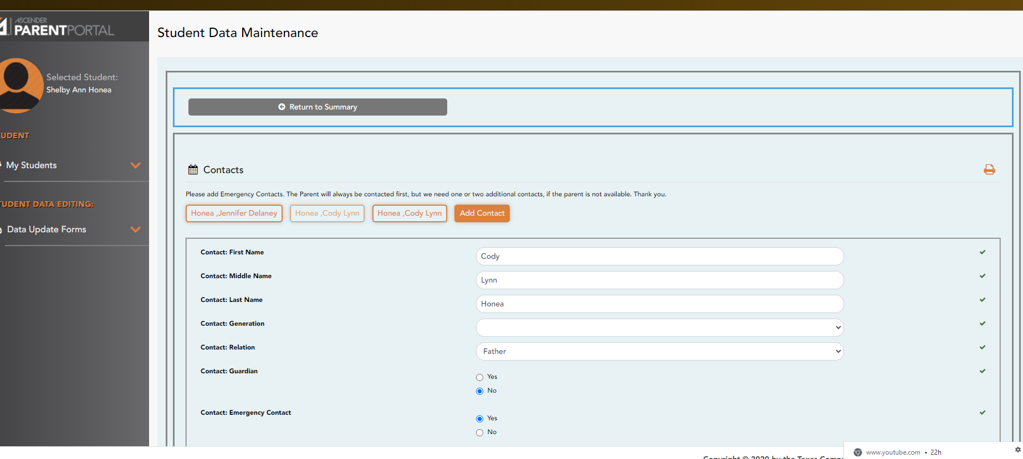

Click on the Orange bar in the middle that says Submit Data with an Electronic Signature. You must do this for each student you have to update their information.

